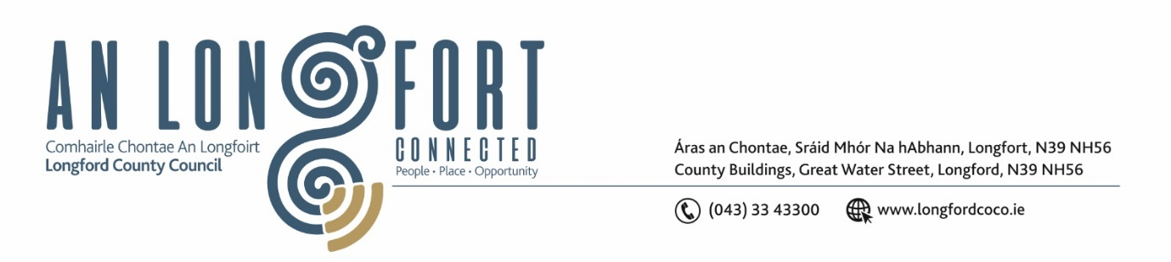

LONGFORD MUNICIPAL DISTRICT

Please note meeting will be held in the Council Chamber, Aras an Chontae and via Microsoft Teams

14 October 2022.

To: Each Member of Longford Municipal District.

Dear Member,

You are requested to attend the Meeting of Longford Municipal District to be held in the Council Chamber, Aras an Chontae and via Microsoft Teams on Wednesday 26 October 2022 at 3.30pm to transact business, as set out on the agenda hereunder.

Yours sincerely,

Ann Marie Mc Keon
_______________
Ann Marie Mc Keon
Meetings Administrator.

AGENDA

Prayer before meeting.

1. Confirmation of Minutes:
- Longford Municipal District Committee Meeting held on Wednesday 28 September 2022 – copy enclosed.
- Longford Municipal District Meeting held on Wednesday 28 September 2022 – copy enclosed.

2. Matters arising from Minutes.
3. Declaration of Interest by Members.

4. Management Report – enclosed.

5. Consideration of the 2023 General Municipal Allocation.

6. Consideration of free parking arrangements during the Christmas period.
7. Longford Town Christmas Lights.
8. Consideration of application from Longford Town Twinning.
9. Notices of Motions, submitted by Councillors, as listed hereunder –

Councillor John Browne
I call on Longford County Council to have the bushes and shrubbery cut and tidied in the car park adjacent to St. Mel’s Cathedral on St. Mel’s Road.
Councillor Gerry Hagan
I call on Longford Municipal District to name the roundabout at Carriglass after Tom Reddington. It is fitting that this will happen this year as it celebrates the 100-year anniversary of Tom Reddington’s death at Carriglass during the Civil War. Tom was Operations Commander for county Longford during the War of Independence.

